Insulin independence achieved with novel stem cell therapy

SAN FRANCISCO – Autologous nonmyeloablative hematopoietic stem cell transplantation achieved insulin independence* in 59% of subjects with new-onset type 1 diabetes at 6 months of follow-up, and in 32% of subjects at up to 48 months of follow-up, results from a multicenter trial showed.
"Exogenous insulin therapy does not always achieve metabolic control in type 1 diabetes, nor prevent the occurrence of complications or halt beta-cell decline," Dr. Francesca D’Addio said at the annual scientific sessions of the American Diabetes Association. "Several clinical trials based on the preclinical successful targeting of innate/adaptive immune responses failed in type 1 diabetes. Recent trials conducted worldwide succeeded in exploiting hematopoietic stem cells [HSCs] to treat new-onset type 1 diabetes."
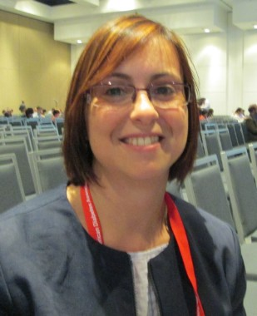
Dr. Francesca D'Addio

Dr. D’Addio of the Boston Children’s Hospital transplant research center noted that the rationale to use HSCs in type 1 diabetes is based on their immunoregulatory properties, "to rescue peripheral tolerance toward pancreatic beta cells." She presented updated results on the worldwide use of autologous HSC transplantation (AHSCT) in patients with type 1 diabetes, in an effort to evaluate potential adverse events "and to explore the successes and potential pitfalls of this novel therapy." Participating centers included the Medical University of Warsaw, the Affiliated Drum Tower Hospital of Nanjing (China), and Shanghai (China) Jiao Tong University.
The researchers screened 65 individuals aged 12-35 years who were diagnosed with type 1 diabetes within the past year and who were positive for at least one autoantibody against beta-cell antigens. Other inclusion criteria included the absence of cardiomyopathy, severe diabetic complications, malignancy, acute and chronic infection, liver disease, kidney diseases, allergic disease, and pregnancy.
At baseline, the mean age of study participants was 20 years, 63% were male, and their mean body mass index was 18 kg/m². Autologous HSCs were administered after mobilization with hemopoietic growth factor granulocyte colony-stimulating factor (G-CSF) plus cyclophosphamide with an induction therapy based on cyclophosphamide and antithymocyte globulin (200 mg/kg and 4.5 mg/kg for 4 and 5 days, respectively).
Dr. D’Addio reported that insulin independence was achieved in 100% of individuals at least once during a follow-up period of up to 48 months, and mainly within the first 6 months after treatment. At the 6-month time point, 59% of patients had achieved insulin independence*, compared with 32% of subjects who were followed up to 48 months.

The researchers also observed a significant decrease in hemoglobin A_{1c} level at 6 months, from a pretreatment level of 87.2 mmol/mol (10.1%) to 42.2 mmol/mol (6.0%) and then maintained over time, as well as a significant increase in C-peptide levels that was maintained up to 48 months (from a pretreatment level of 0.5 ng/mL to 1.2 ng/mL).
Slightly more than half of patients (52%) experienced adverse events, primarily neutropenic fever (seven cases), alopecia/gastric tract symptoms (five cases), and alopecia/fever (three cases). Treatment responders, defined as those who were insulin dependent at least 6 months after transplantation, showed improved glycometabolic status and beta-cell function, compared with nonresponders. They also had a greater number of CD34-positive cells injected.
"The response to AHSCT depends on the number of CD34-positive cells injected and relies on their immunoregulatory properties," Dr. D’Addio concluded. "HSC-based safer therapeutic options are required, including engineering of HSCs."
Dr. D’Addio said she had no relevant financial conflicts to disclose.

